**Development Network:**

1. Design and build 2-tier architecture with two subnets named web and db and launch instances in both subnets and name them as per the subnet names.

2. Make sure only the web subnet can send internet requests.

3. Create peering connection between production network and development network.

4. Setup connection between db subnets of both production network and development network respectively.

Create VPC 2

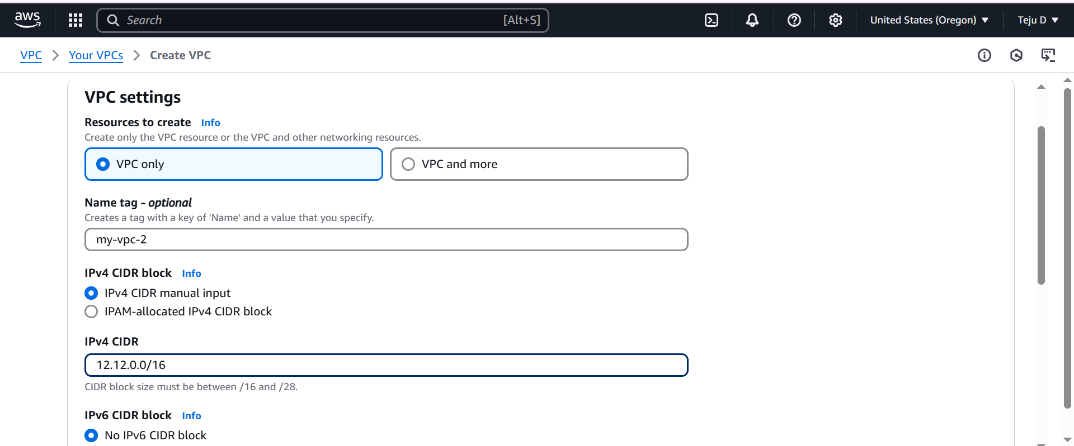

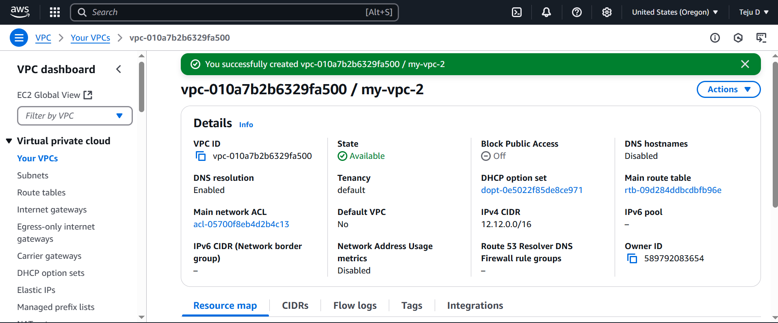

Name the routetable which is already created and Create another routetable named vpc-2-no-int

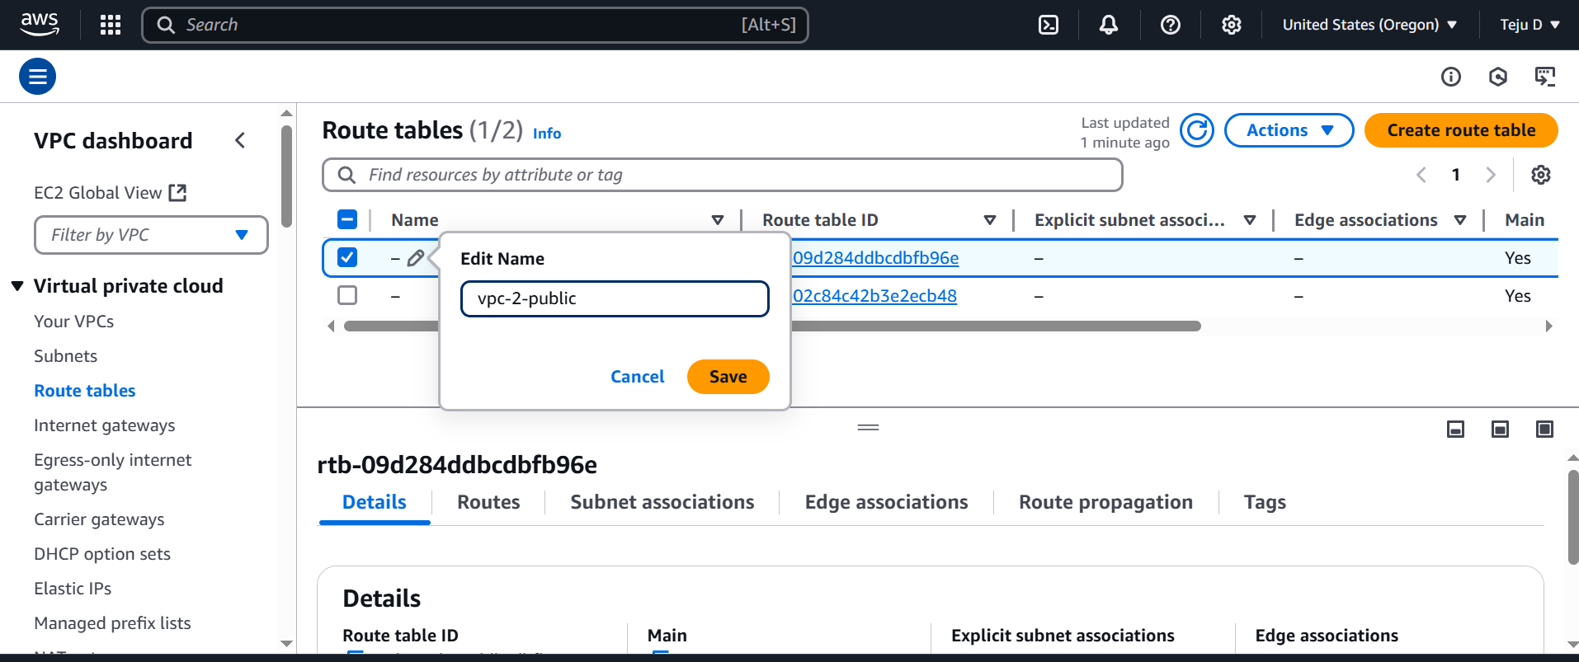

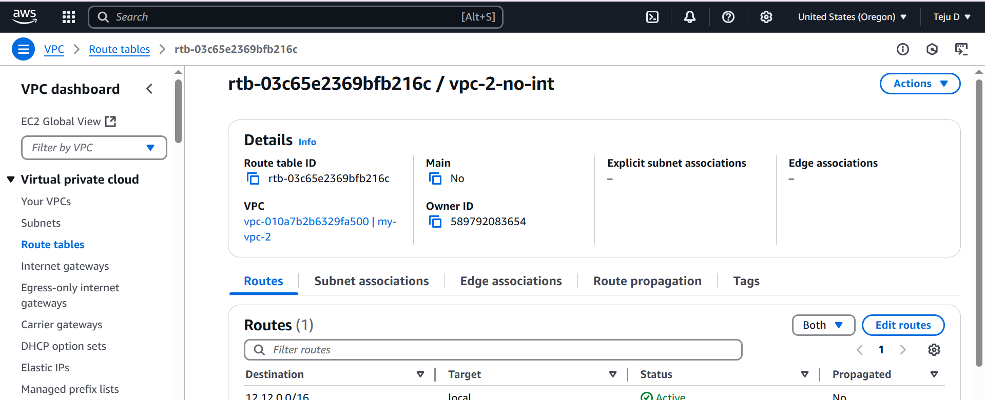

Create Public and Private Subnet

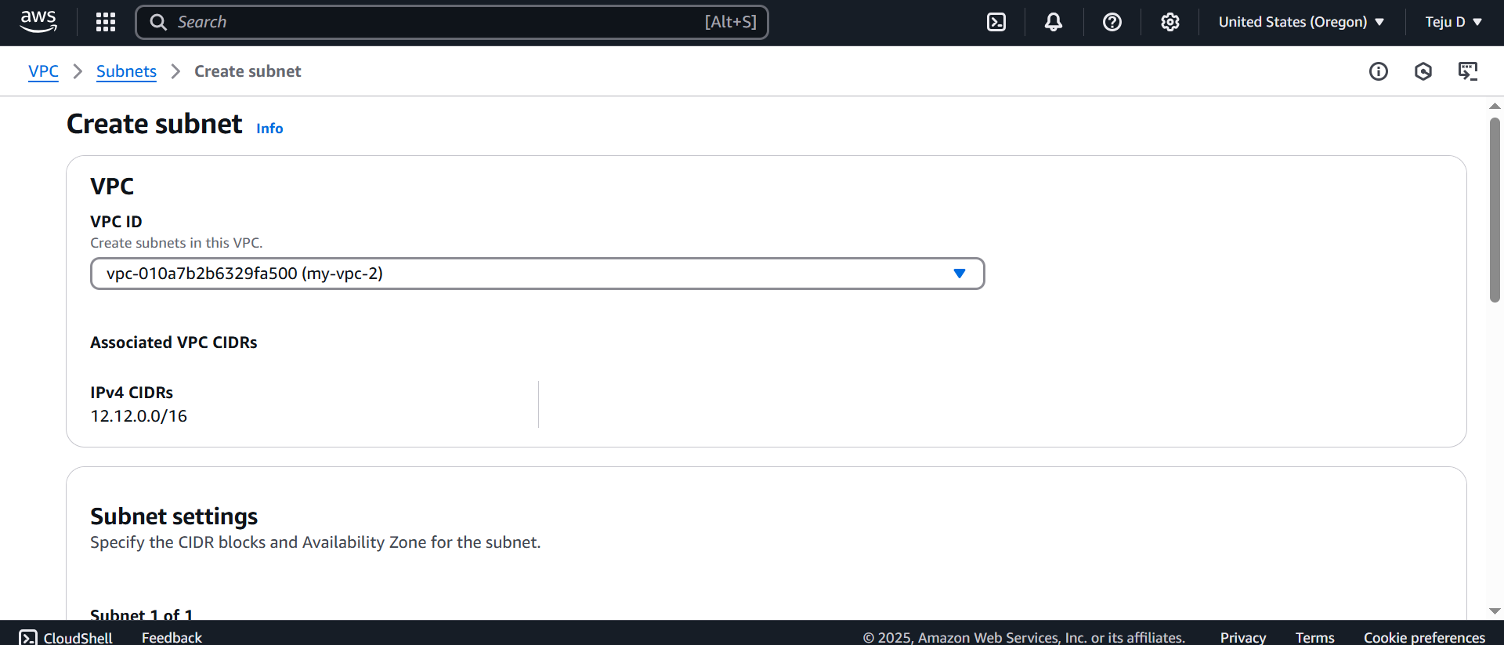

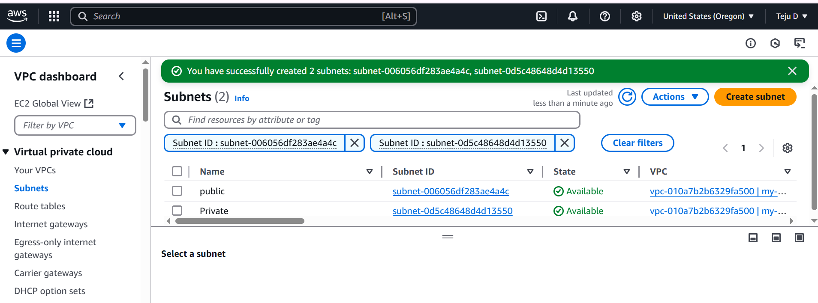

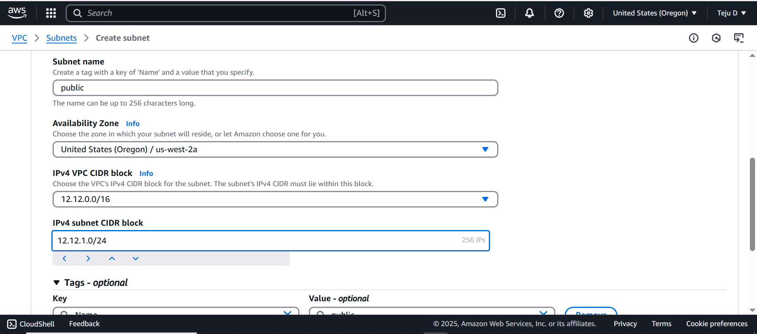

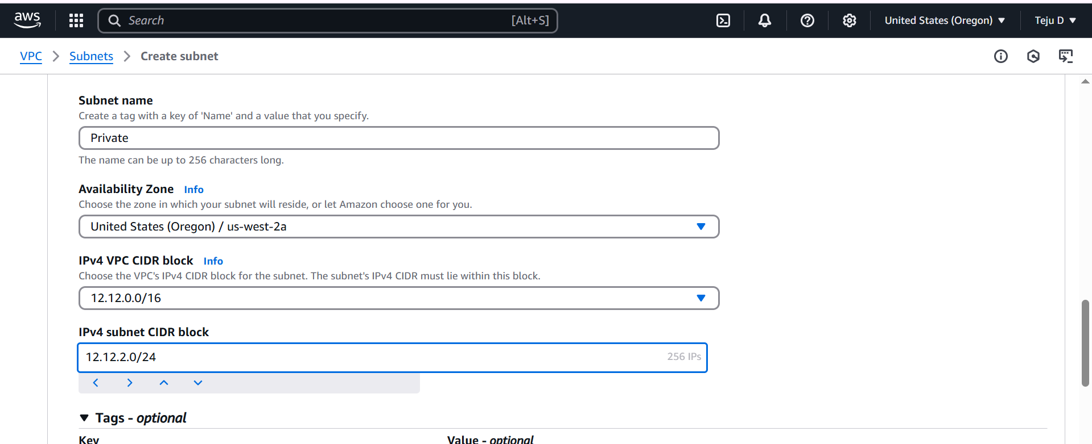

Create Internet Gateway

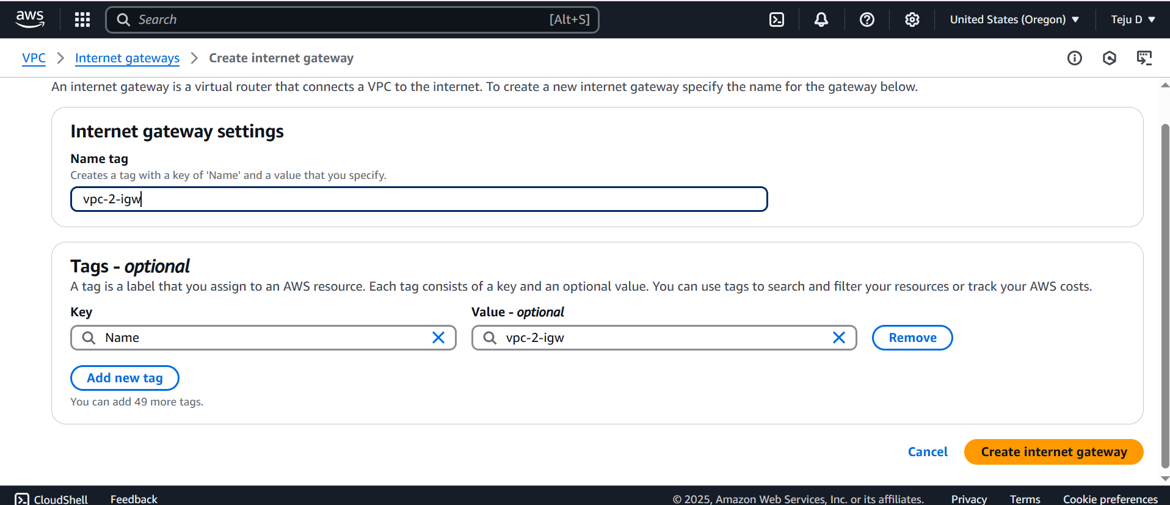

Attach it to VPC 2

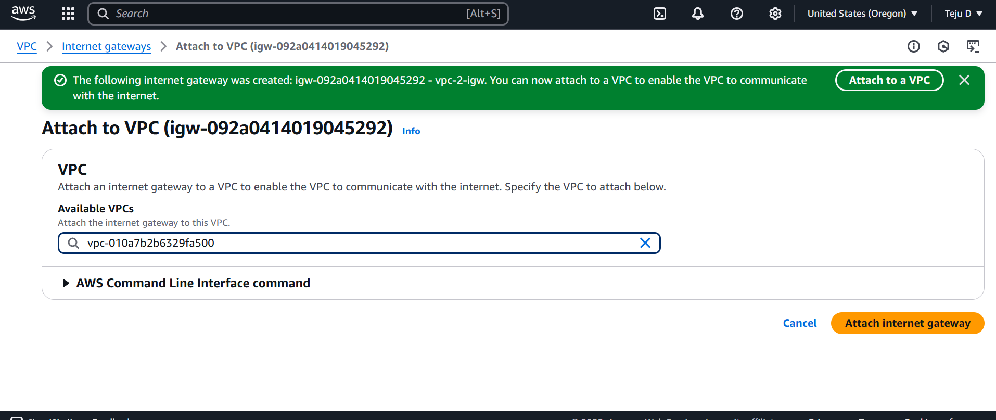

Go to routetable – vpc-2-public routetable – edit routes – **save changes**

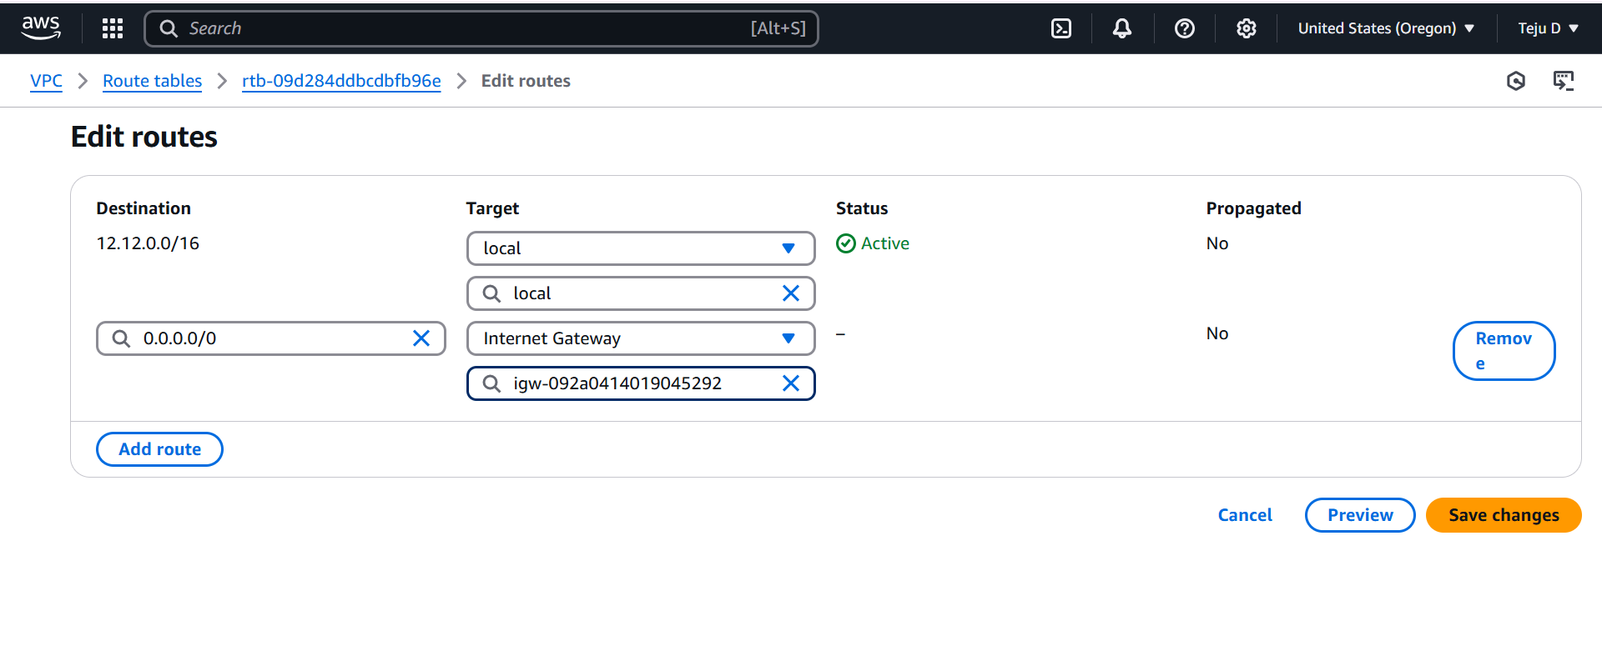

subnet association - Edit subnet association- **save changes**

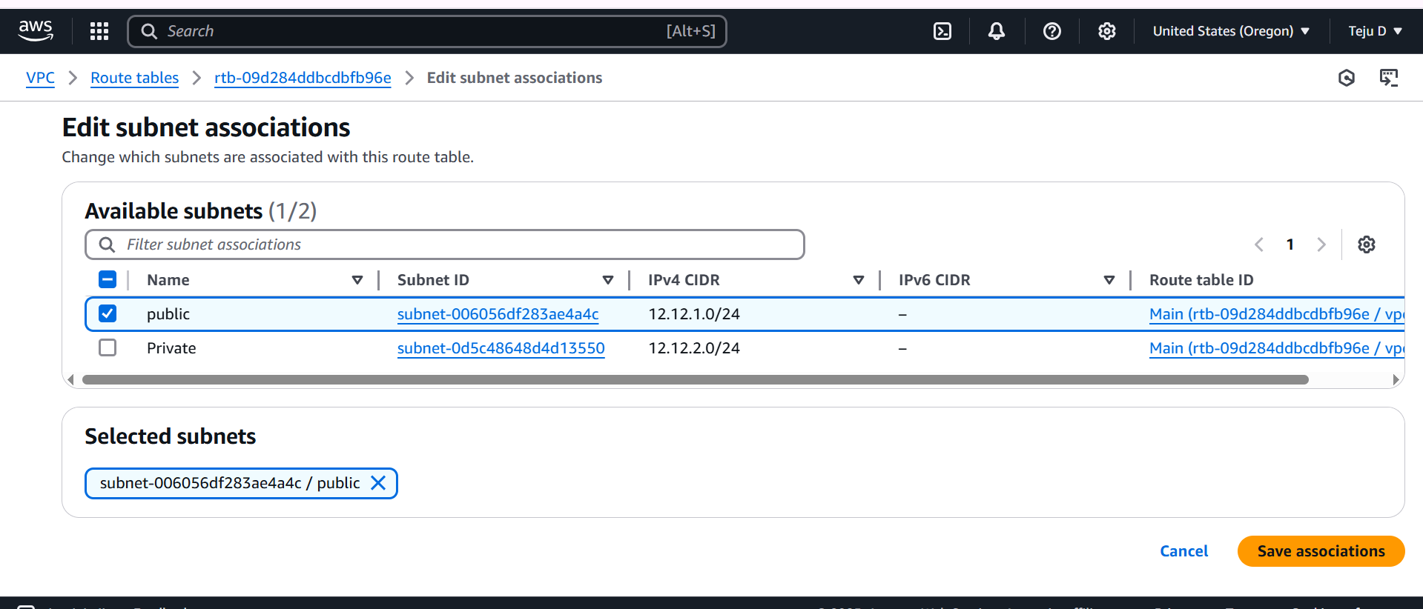

Go to routetable – vpc-2-no-int – subnet association - Edit subnet association-select private- **save association**

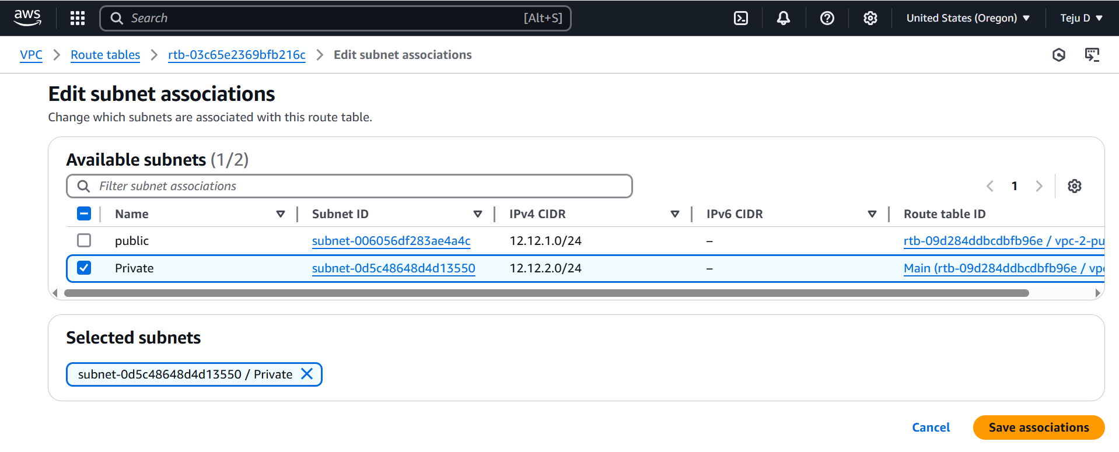

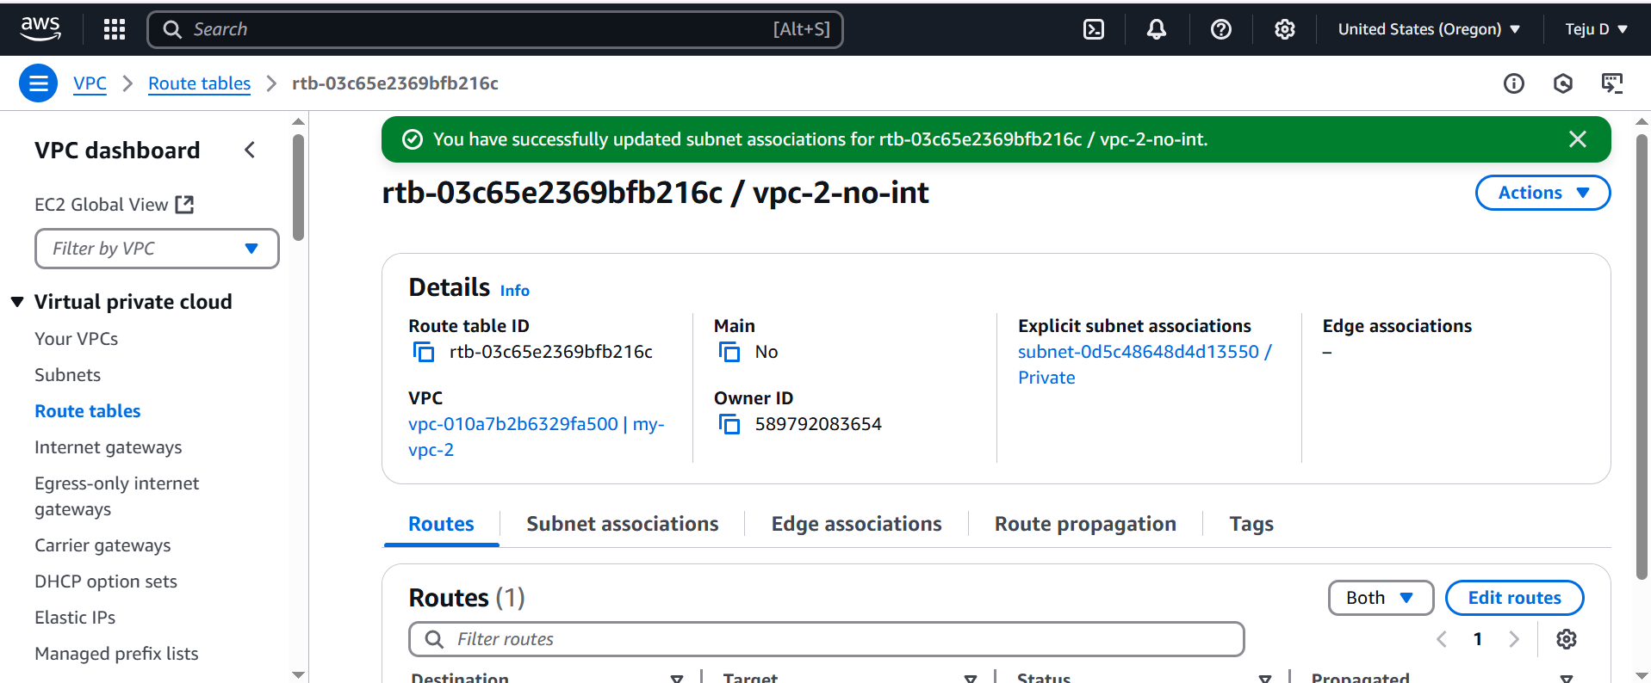

Launch instance for public

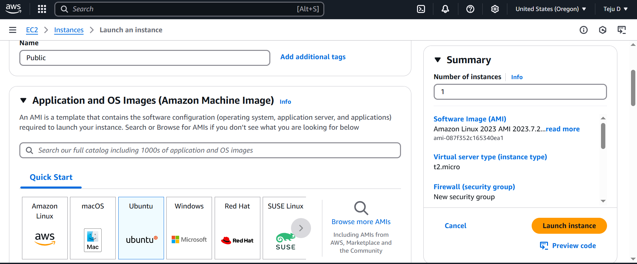

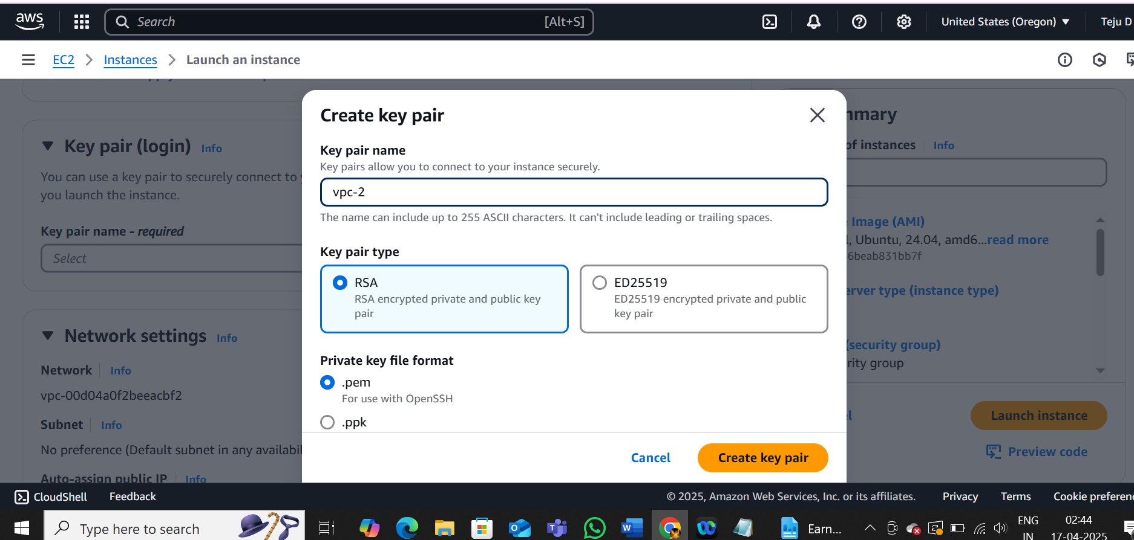

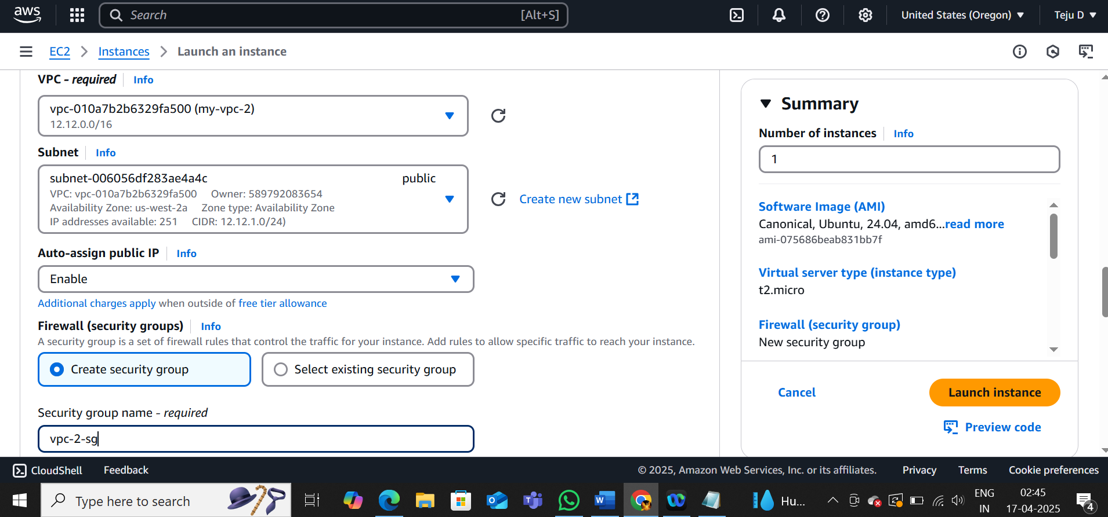

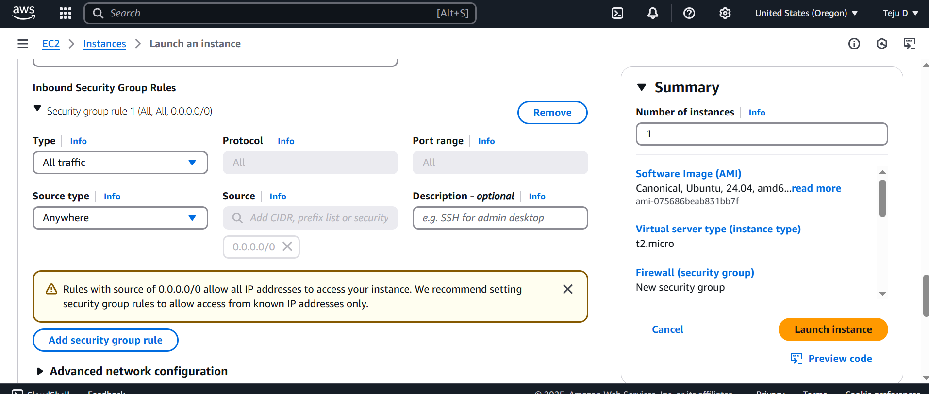

Launch instance for private

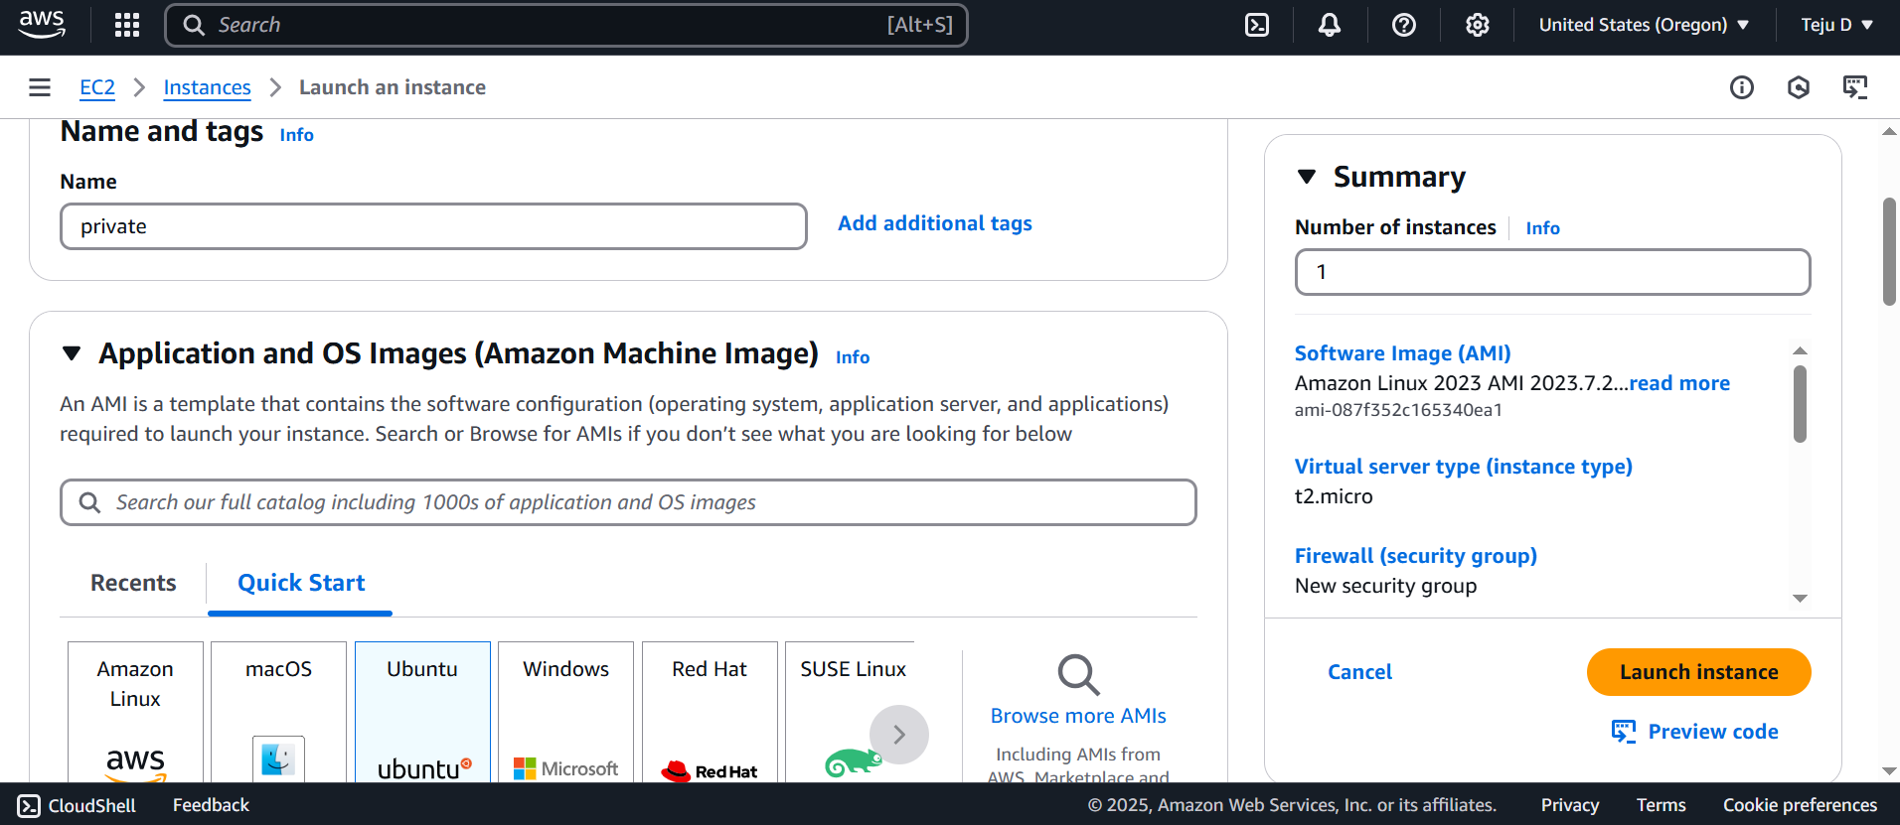

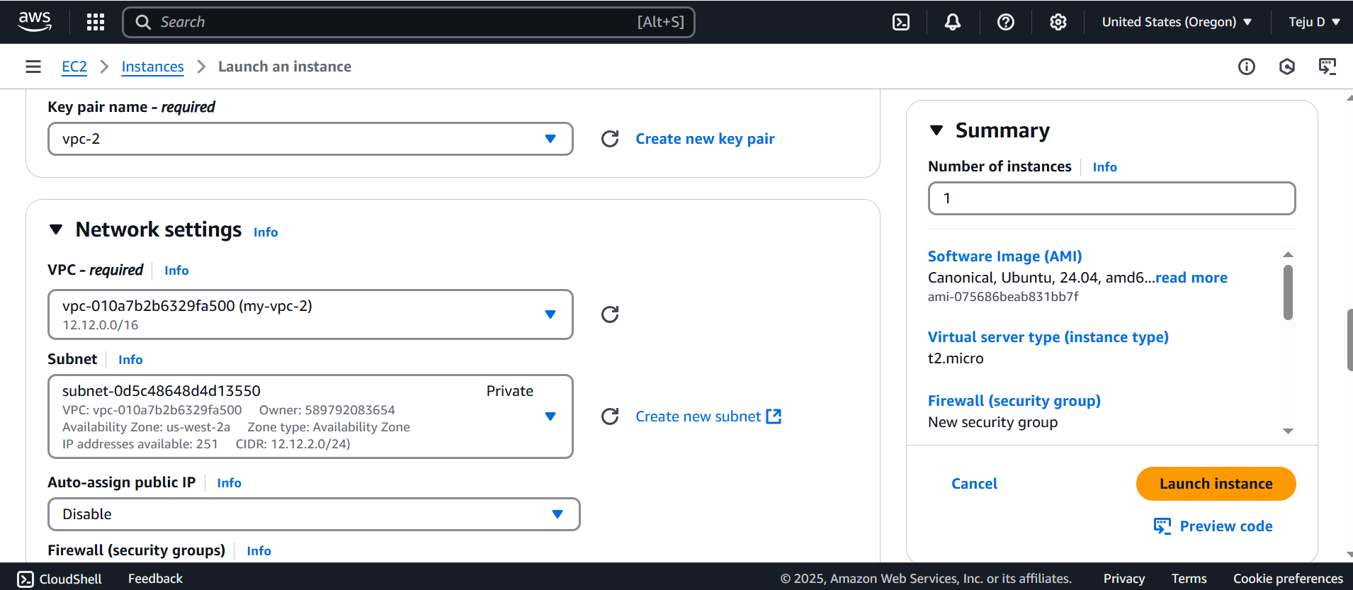

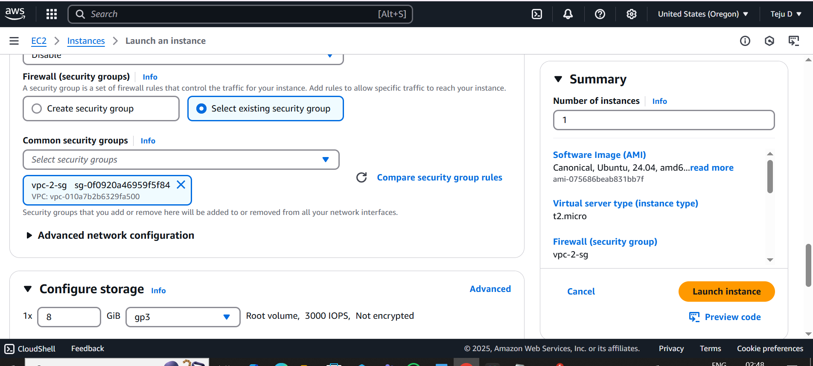

Connect to the instance public server directly. Follow the below commands

* Sudo apt-get update
* Ping aws.com

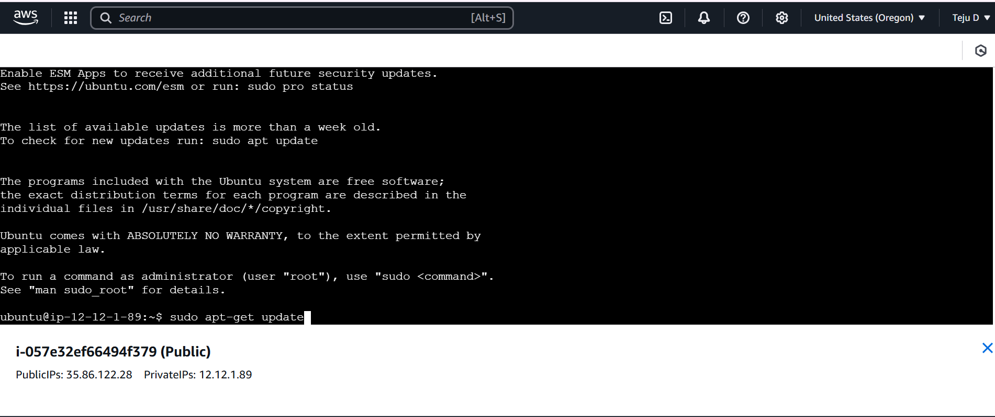

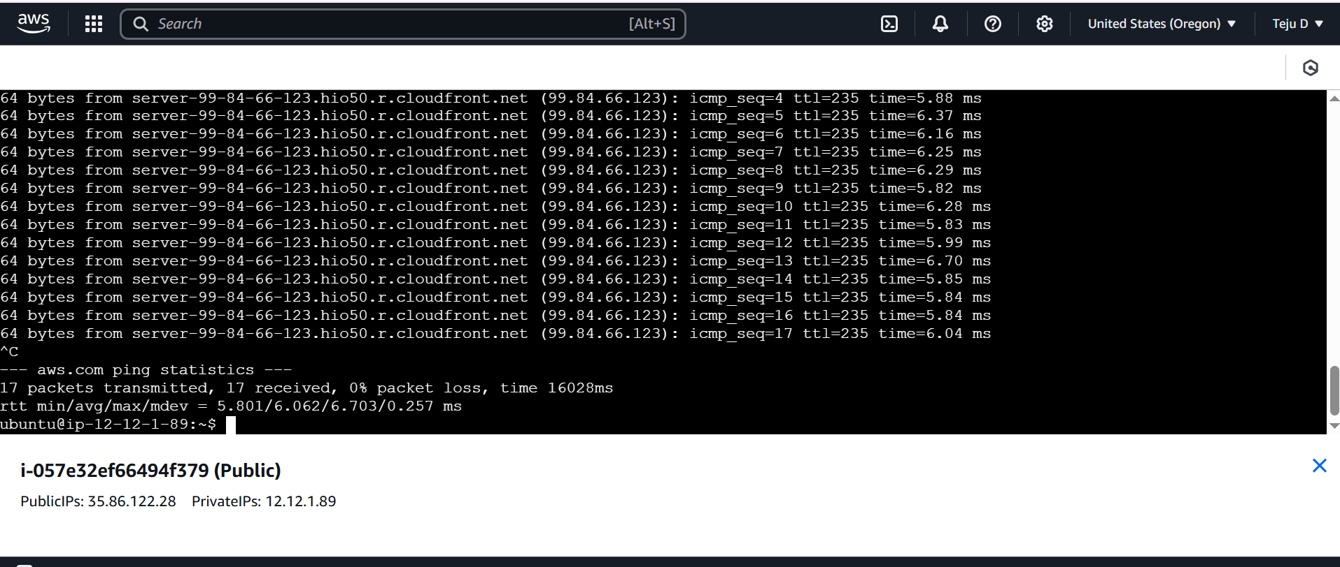

Go to north virginia region – VPC – peering connection - create peering connection

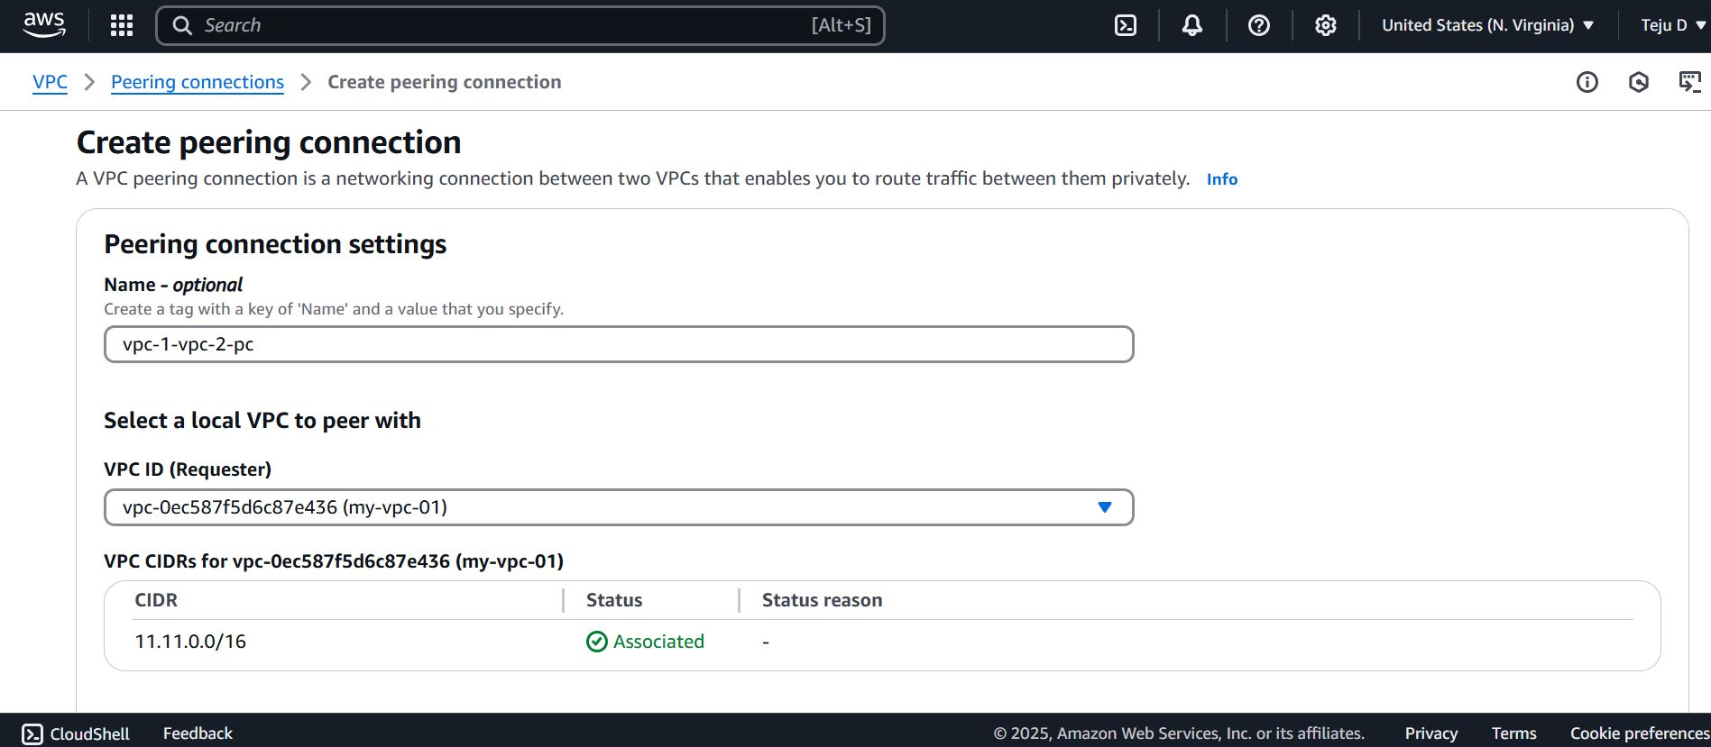

Go to the Oregon region – copy the vpc id and paste it in the N.Virginia

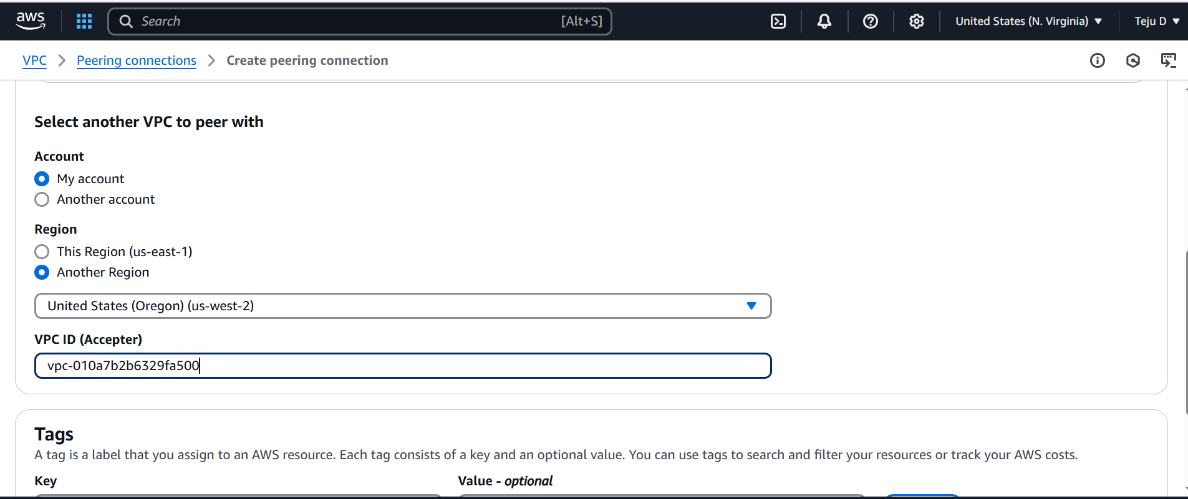

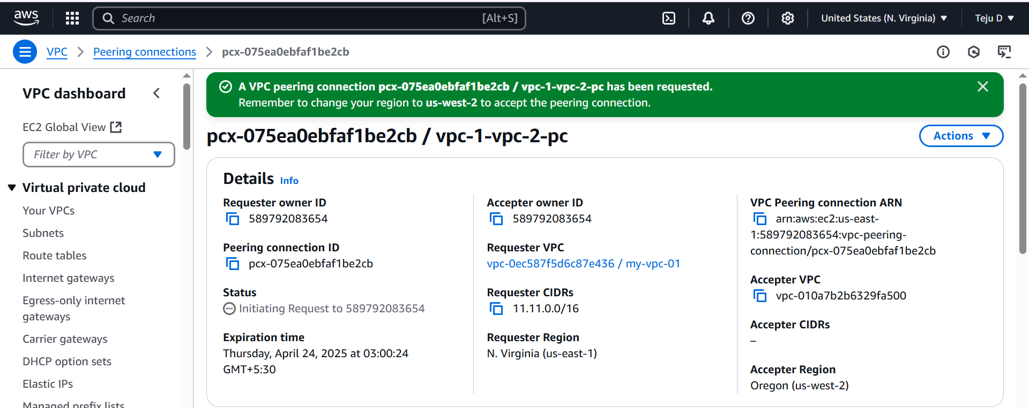

To checking peering, go to the Oregon region – peering connection – accept request

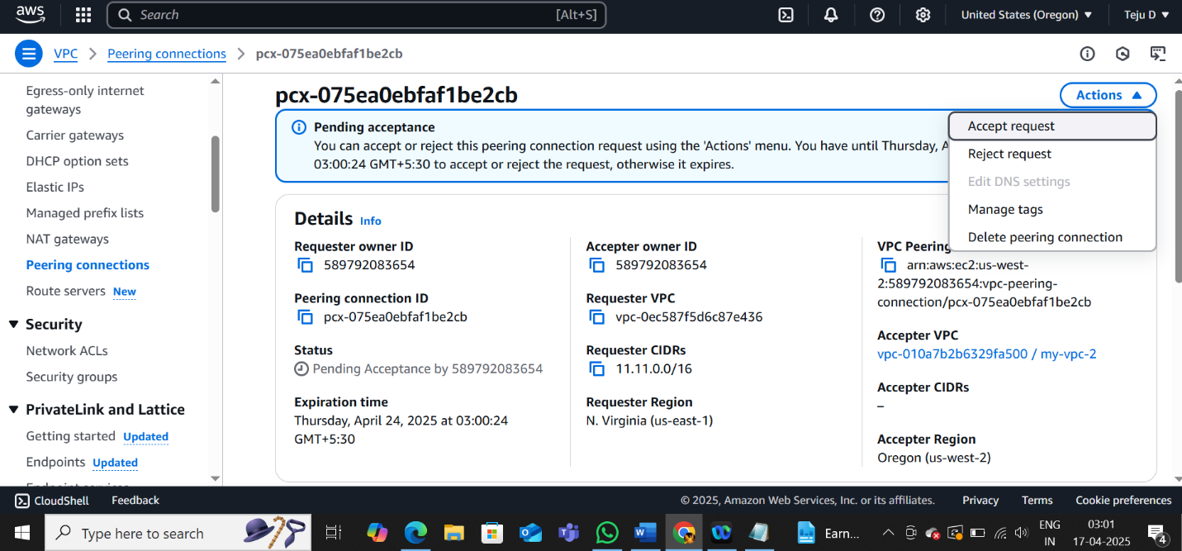

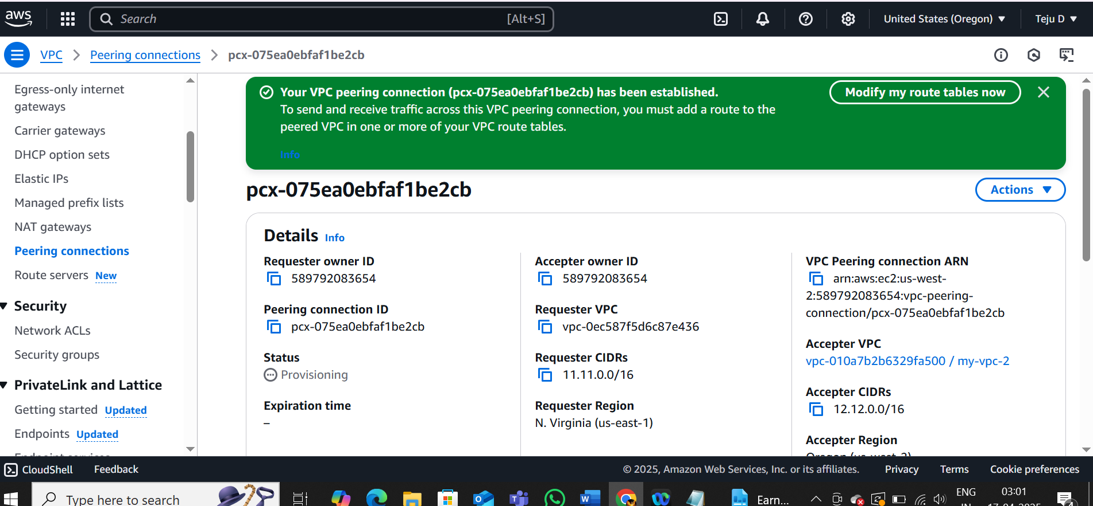

N.Virginia – routetables – VPC1-no-int – routes – edit routes – add route

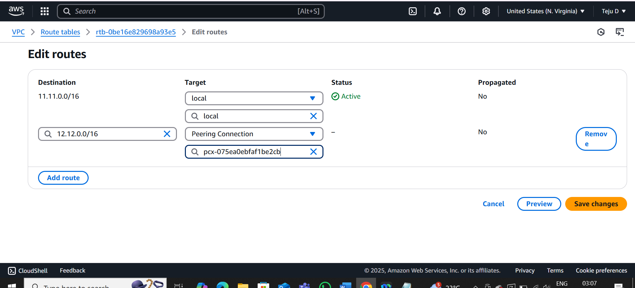

Oregon – routetables – VPC-2-no-int – routes – edit routes – add route

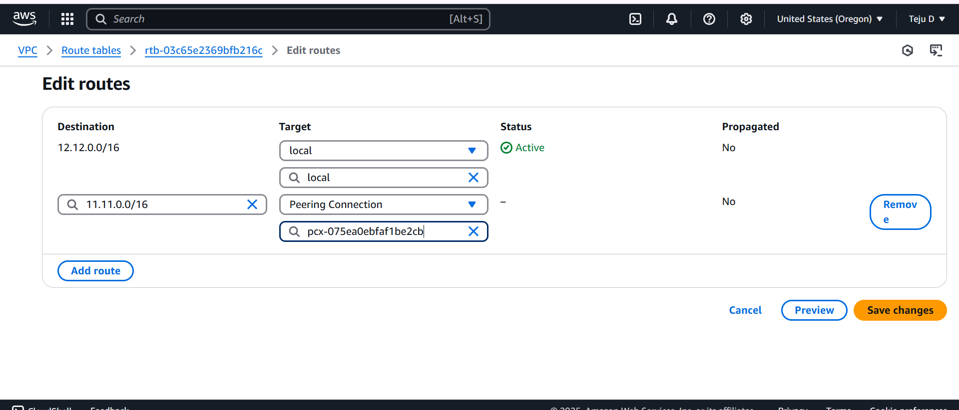

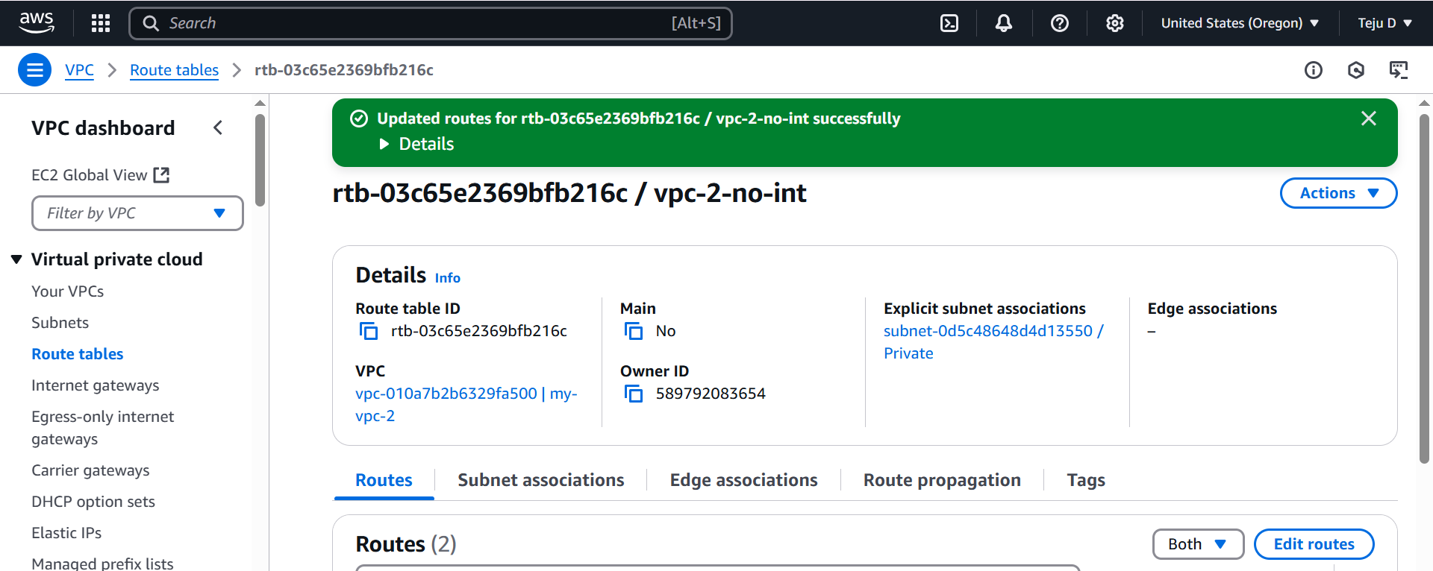

Connect private instance – go to ssh – copy pem file name

* Sudo nano vpc-2.pem

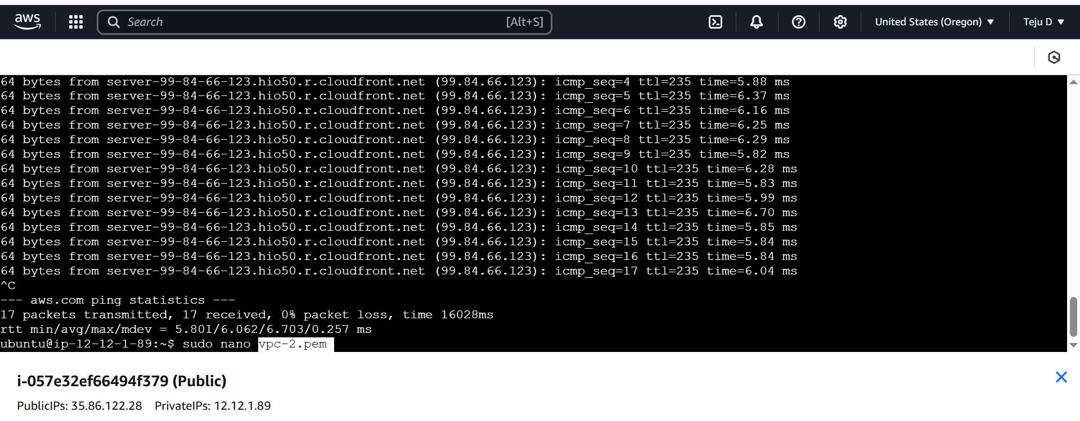

Copy paste the pem file content

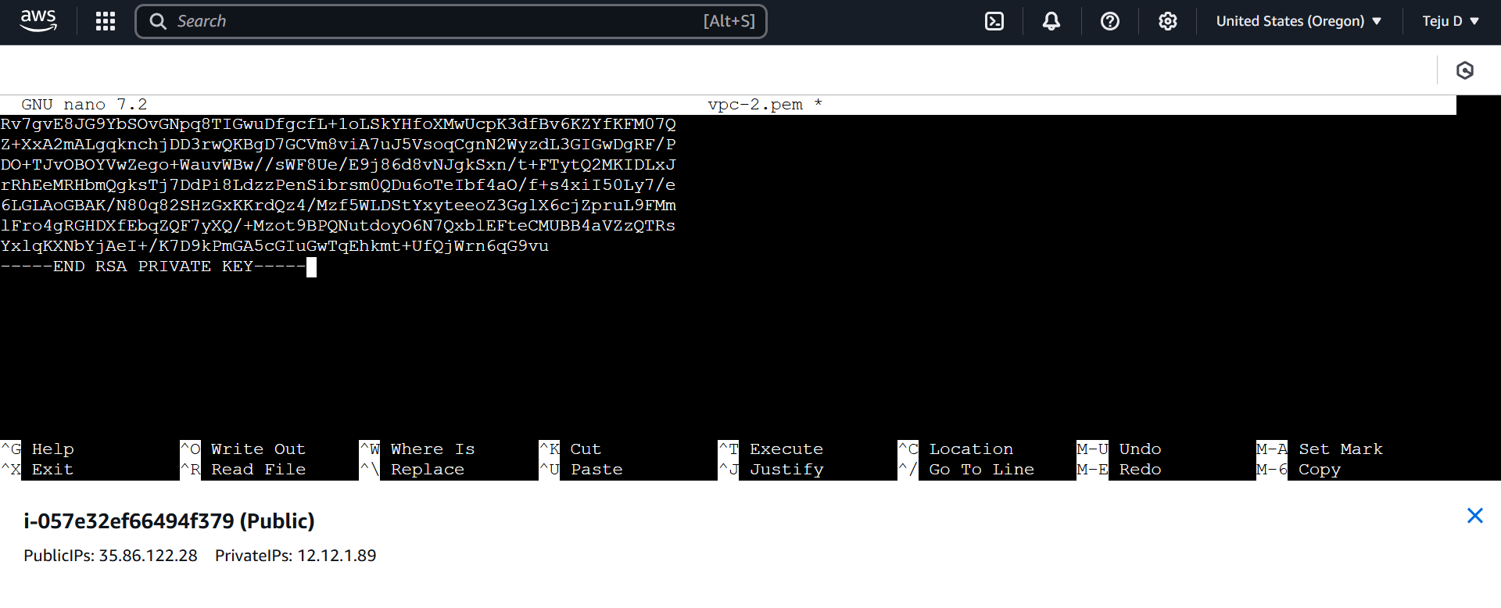

* Ctrl+S and Ctrl+X
* Sudo chmod 400 "vpc-2.pem"
* Sudo ssh -i "vpc-2.pem" [ubuntu@12.12.2.48](mailto:ubuntu@12.12.2.48)
* Sudo apt-get update

You will not able to update since there is no NATGateway

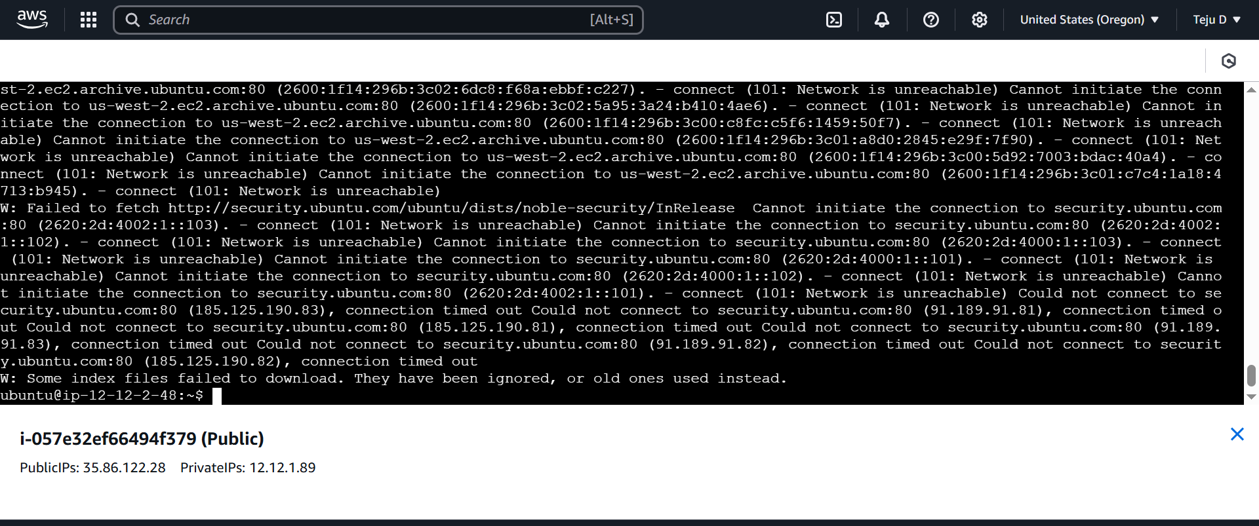

However, you can still update it. Go to N.Virginia region – connect private 3 instance which has no int – ssh client – copy the private IP 11.11.4.222

